caXchange Hub

caXchange – ScenPro, Inc.
Ekagra

Use Case Specification Document

Document Change History
Version Number | Date | Contributor | Description
V1.0 | 10/23/2007 | Steve Chernyak | Initial Draft
V1.0 | 11/23/2007 | Kalpesh Patel | Initial Draft
V1.1 | 1/30/2008 | Michael Holck & David Dorman | Combined first and second iteration use cases for the hub


Updated February 1, 2008

Table of Contents
1. Background/Summary 3
1.1 caXchange Hub 2
1.2 Common Logging Module Integration 2
2. Introduction 3
2.1 Document Overview 3
2.2 Related Documents 3
3. Actors and Authorization 5
3.1 Roles & Responsibilities: 5
3.2 Authorization Levels: 5
4. General Functions 6
4.1 Component View 6
4.1.1 caXchange Hub Component View 6
4.1.2 Common Logging Module Component View 7
4.2 caXchange Component Use Case Model 8
5. Application & Role Specific Use cases 9
5.1 caXchange Client Query 9
5.1.1 USE CASE DESCRIPTION 9
5.1.2 BASIC FLOW OF EVENTS: 10
5.1.3 SEQUENCE DIAGRAM 11
5.2 caXchange Client Receive Message 12
5.2.1 USE CASE DESCRIPTION 12
5.2.2 BASIC FLOW OF EVENTS: 14
5.2.3 SEQUENCE DIAGRAM 14
5.3 Administrator Manage caXchange Hub Use Case 15
5.3.1 USE CASE DESCRIPTION 15
5.3.2 BASIC FLOW OF EVENTS: 17
5.3.3 SEQUENCE DIAGRAM 17
5.4 Assumptions and Constraints 18
5.4.1 ASSUMPTIONS 18
5.4.2 CONSTRAINTS 18
6. System Specific Use Cases 19
6.1 caXchange Audit Service Use Case 19
6.1.1 USE CASE DESCRIPTION 19
6.1.2 SEQUENCE DIAGRAM 23
6.2 caXchange Authenticate Message Use Case 24
6.2.1 USE CASE DESCRIPTION 24
6.2.2 BASIC FLOW OF EVENTS: 26
6.2.3 SEQUENCE DIAGRAM 26
6.3 caXchange Outbound Message Use Case 27
6.3.1 USE CASE DESCRIPTION 27
6.3.2 BASIC FLOW OF EVENTS: 29
6.3.3 SEQUENCE DIAGRAM 29
6.4 caXchange Route Message Use Case 30
6.4.1 USE CASE DESCRIPTION 30
6.4.2 BASIC FLOW OF EVENTS: 33
6.4.3 SEQUENCE DIAGRAM 33
6.5 Assumptions and Constraints 34
6.5.1 ASSUMPTIONS 34
6.5.2 CONSTRAINTS 34
7. Use Case Change Management & Traceability 35
7.1 Overview 35
7.2 Change Management Tracking Matrices 35
7.3 Use Case Traceability Matrices 35
8. Overall Requirements 36
8.1 caXchange Component Requirements 36
8.2 caXchange Hub Administrator 38

Background/Summary

caXchange Hub
The caXchange Hub is the software component that is primarily responsible for receiving input from various external systems, routing the input to various services that are hosted on the hub, and eventually routing the output of those services to external systems. caXchange is implemented using Servicemix 3.1.2 enterprise service bus (ESB) for routing and exposing that functionality using a service deployed on caGrid. caXchange is deployed as a service assembly on Servicemix 3.1.2. caXchange grid service acts as a proxy to the service assembly.

Common Logging Module Integration
The Common Logging Module (CLM) provides the audit and logging services under caCORE set of tools. It includes a set of tools such as the log-locator web application. Integrating CLM with caXchange for logging enables the use of these tools for caXchange logs.

Introduction

Document Overview
This Use Case Specification document defines the Functional Requirements for the caXchange Hub, version 1.0, within the context specific scenarios. The scenarios detail user defined activities required of the application and supporting systems to complete tasks and functions that are necessary to meet user occupational requirements. The scenarios are represented in step-by-step responsibility-based workflow for each actor that will use/interact with caXchange Hub.

Related Documents
Document Name | Version | Location
caXchange Use Case Specification and Realization Document | 1.0 | https://gforge.nci.nih.gov/plugins/scmcvs/cvsweb.php/caxchange/Deliverables/Use%20Case%20Specification%20and%20Realization%20Documents%20(Task%202.1).rtf?cvsroot=caxchange
caXchange Software Requirements Specification Document | 1.0 | https://gforge.nci.nih.gov/plugins/scmcvs/cvsweb.php/caxchange/Deliverables/Software%20Requirement%20Specifications%20(Task%202.2).doc?cvsroot=caxchange
caXchange Interface Specification |  | https://gforge.nci.nih.gov/plugins/scmcvs/cvsweb.php/caxchange/Documentation/Interface/caXchange_Interface_Specification.doc?cvsroot=caxchange
caXchange Design Diagram |  | https://gforge.nci.nih.gov/plugins/scmcvs/cvsweb.php/caxchange/Documentation/Design/reliable-messaging-diagram.odg?cvsroot=caxchange
caXchange Use Case Specification and Realization Document | 1.0 | https://gforge.nci.nih.gov/plugins/scmcvs/cvsweb.php/caxchange/Deliverables/Use%20Case%20Specification%20and%20Realization%20Documents%20(Task%202.1).rtf?cvsroot=caxchange
Common Security Module | 3.2 | http://ncicb.nci.nih.gov/infrastructure/cacore_overview/csm
caCORE 3.2_Tech_Guide (Chapter 10: Common Logging Module)
CSM – User Provisioning Tool User Guide |  | (ftp://ftp1.nci.nih.gov/pub/cacore/CSM/UPT_User_Guide.pdf)
Log Locator Tool user guide | 3.2 | http://gforge.nci.nih.gov/frs/download.php/2673/LLT_User_Guide.pdf
Servicemix Documentation |  | http://servicemix.apache.org/documentation.html
Java Business Integration Specification |  | http://jcp.org/en/jsr/detail?id=208

Actors and Authorization

Roles & Responsibilities:
Actor Actions | System Responsibilities | Dependency/Comments
caXchange Client | Sends a caXchangeRequest message to caXchangeGridService.
caXchange Administrator | Performs system level maintenance (i.e. deploy, startup, monitor, shutdown)
caXchange Grid Service | Forwards incoming requests to caXchange for processing. To keep track of a request it creates a WS-Resource framework resource. The grid service then returns an EndPointReference to the client. The client uses this end point reference to invoke the getResponse operation. The grid service also creates a response listener, which listens for caXchangeResponse and updates the resource. Please see the caXchange Interface Specification document for details of the operations it exposes.
caXchange Service Assembly | Deployed on the Servicemix JBI container
caXchange Common Logging Module | Implements the interface/integration between CLM and caXchange by implementing the ExchangeListener interface.
caXchange Response Listener | Listens for the response on the jms queue associated with the response outbound component of the caXchange service assembly. Once a response is received from the queue, the resource associated with the corresponding request is updated. The client can then use the getResponse method to get the caXchangeResponse.

Authorization Levels:
The authentication and authorization will be the Grid Authentication and authorization technology to accept a user’s grid credentials. The webSSO implementation (that is based on Grid authentication and authorization) that is currently being developed by caGrid team will be utilized for the CCTS project and caXchange will integrate for user level authentication and authorization.

Refer to caXchange design documentation for additional information.

General Functions

Component View

caXchange Hub Component View
The following identifies and describes the caXchange Hub system level interactions and operations.

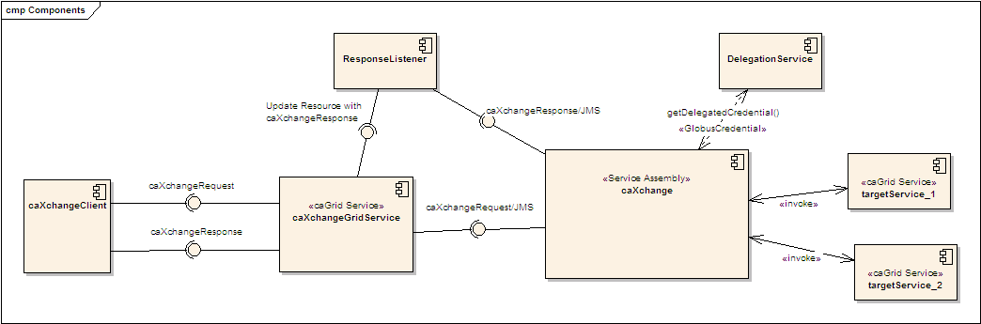
Figure 1 caXchange Hub Components

- A caXchange client sends a caXchangeRequest message to caXchangeGridService.
- caXchangeGridService is a caGrid service which acts as a proxy for the caXchange service assembly deployed on Servicemix JBI (Java Business Integration) Container.
- caXchangeGridService creates a WS-Resourceframework Resource associated with the caXchangeRequest. This caXchangeRequest is then forwarded to the caXchange service assembly for processing. This is done by pushing caXchangeRequest message to the jms inbound component of caXchange service assembly.
- caXchange service assembly then invokes the DelegationService for the authorization credentials before routing the request message based on the message type. Please refer to the caXchange detailed design diagram for routing details.
- Outbound components then invoke the target services.
- Responses from the target services are then composed into a caXchangeResponse message.
- caXchangeResponse is then pushed to the jms outbound component.
- The response listener then picks up the caXchangeResponse and updates the WS-Resourceframework resource created in step 3.
- The caXchangeResponse is then available to the client.

Common Logging Module Component View
The following identifies and describes the Common Logging Module Component View level interactions and operations.

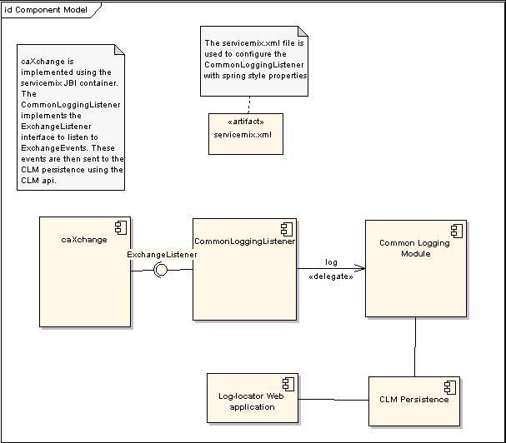
Figure 2 Common Logging Module Component View

- CommonLoggingListener registers with the caXchange Servicemix JBI Container to listen for all ExchangeEvents.
- Servicemix JBI Container sends ExchangeEvents all registered ExchangeListeners ExchangeEvents.
- CommonLoggingListener logs the exchange events using the Common Logging Module.
- CommonLoggingListener can be configured using servicemix.xml with spring style configuration.

caXchange Component Use Case Model
The following represents the use case model for the caXchange components.

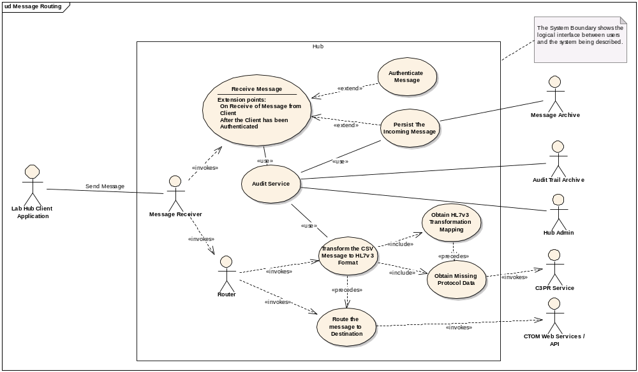Figure 3 caXchange Component Use Case Model

Application & Role Specific Use cases

caXchange Client Query
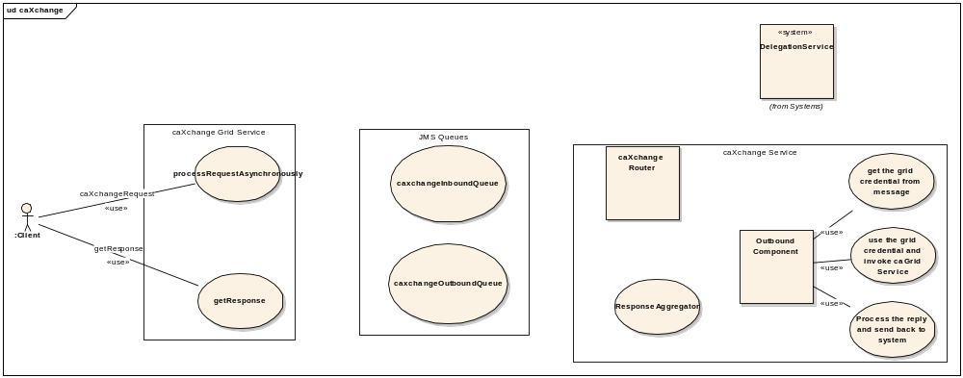
Figure 4 caXchange Client Query Use Case Diagram

USE CASE DESCRIPTION
Use Case Name | Grid Services
Use Case ID | HUBcaXQY_1.0
Primary Actor | - caXchange Client
Secondary Actor | Not Defined
Brief Description | Stimulate request for data
Trigger | Actor initiated
Pre-conditions | System and supporting components are operational and available
Primary Flow of Events | - Make caXchangeRequest  - Query JMS (system specific)  - Stimulate getResponse
Secondary Flow of Events | Not Defined
Post Conditions | The correct data is viewed and managed by authorized actors
Branch Point
Associated Quality Requirement(s)
Related Use Cases
Business Rules

BASIC FLOW OF EVENTS:
The user queries for data using caXchange Hub in the following way:
- Make caXchangeRequest
- Query JMS (system specific)
- Stimulate getResponse
- Ends

SEQUENCE DIAGRAM
The sequence diagram below shows the basic sequence for querying data from the caXchange.

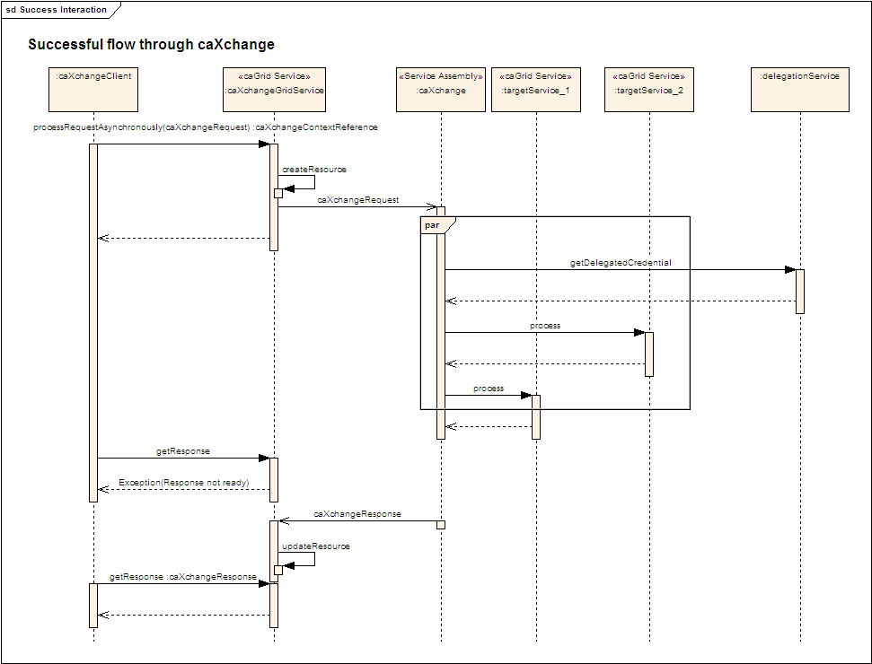

Figure 5 caXchange Query Sequence Diagram

caXchange Client Receive Message
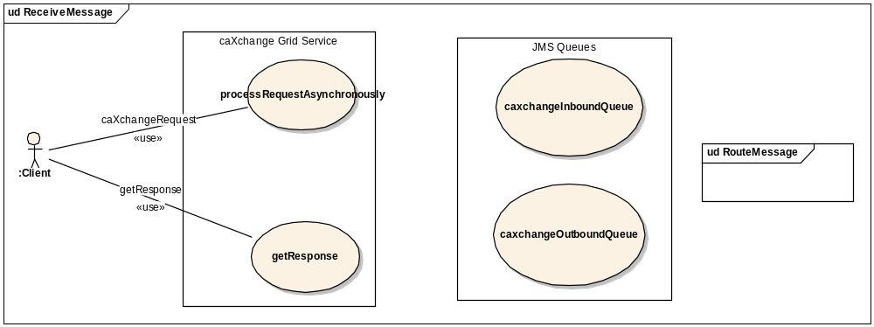
Figure 6 caXchange Client Receive Message Use Case Diagram

USE CASE DESCRIPTION
Use Case Name | Grid Services
Use Case ID | HUBcaXGM_2.0
Primary Actor | - caXchange Client - Sends a request to the caXchange Grid Service for processing.
Secondary Actor | - caXchange Grid Service – The caXchange Grid Service that serves as a proxy interface to caXchange for processing incoming requests.  - Inbound Component – The binding component that takes incoming requests from the caXchange Grid Service.  - caXchange – The caXchange service that picks up the requests from the inbound component, and performs the routing for the request and response.  - Response Component – The binding component that gets responses from caXchange and makes them available to the caXchange Grid Service.
Brief Description | Receive data from client stimulated request
Trigger | Client sends a request to caXchange for processing.
Pre-conditions | - caXchange Grid Service is up.  - Inbound component is up for receiving messages.  - Response component is up and available for getting responses from caXchange.  - caXchange service assembly is deployed to ESB, started and running.
Primary Flow of Events | - caXchange Grid Service – Gets a response from a client to process the request.  - caXchange Grid Service – Creates a WSRF resource associated with this request.  - caXchange Grid Service – Forwards the request to caXchange inbound component for processing.  - caXchange Grid Service – Returns an EndPointReference to the client representing there processing request. Client can use this EndPointReference to get the status of their request, and the response.  - Client – Client uses the EndPointReference to obtain the status of the request submitted to caXchange. The EndPointReference serves as an acknowledgement that the request is submitted successfully for processing.  - Use case ends.
Secondary Flow of Events | - caXchange Grid Service is not available. - The client gets an error sending the message to caXchange.  - Inbound Component is not available. - The caXchange Grid Service composes an error response. This error response is returned to the client.  - caXchange Grid Service gets an error submitting message to the inbound component. - The caXchange Grid Service composes an error response. This error response is returned to the client.  - caXchange Grid Service crashes. - The caXchange Grid Service is able to recover requests that had been submitted to caXchange for processing. Clients can get the responses for these requests as they become available from the Response Component.
Post Conditions | - Processing details are captured in a log.  - The request is submitted to caXchange for processing.  - The client has the EndPointReference to obtain the status of the request submitted to caXchange.
Branch Point
Associated Quality Requirement(s)
Related Use Cases
Business Rules

BASIC FLOW OF EVENTS:
The user queries for data using caXchange Hub in the following way:
- caXchange Grid Service – Gets a response from a client to process the request.
- caXchange Grid Service – Creates a WSRF resource associated with this request.
- caXchange Grid Service – Forwards the request to caXchange inbound component for processing.
- caXchange Grid Service – Returns an EndPointReference to the client representing there processing request. Client can use this EndPointReference to get the status of their request, and the response.
- Client – Client uses the EndPointReference to obtain the status of the request submitted to caXchange. The EndPointReference serves as an acknowledgement that the request is submitted successfully for processing.
- Use case ends.

SEQUENCE DIAGRAM
The sequence diagram below shows the basic sequence for querying data from the caXchange.

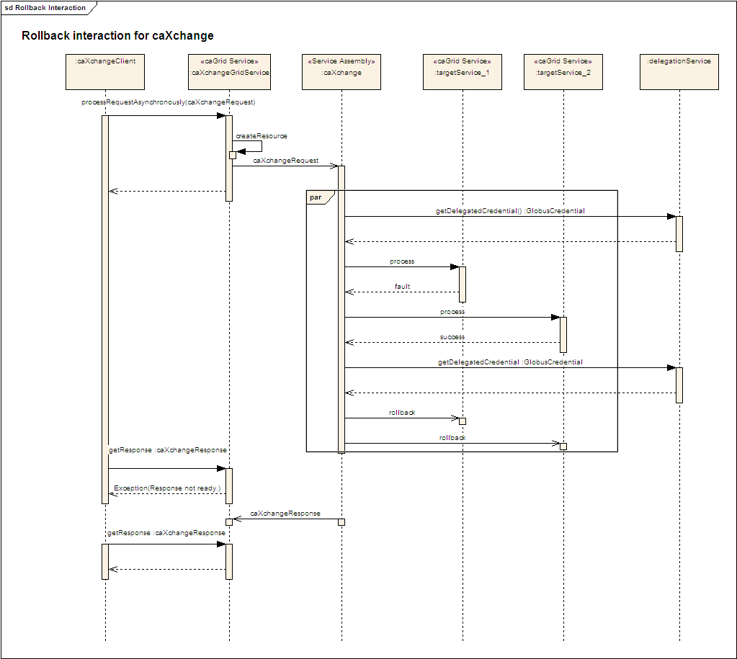
Figure 7 caXchange Client Receive Message Sequence Diagram

Administrator Manage caXchange Hub Use Case
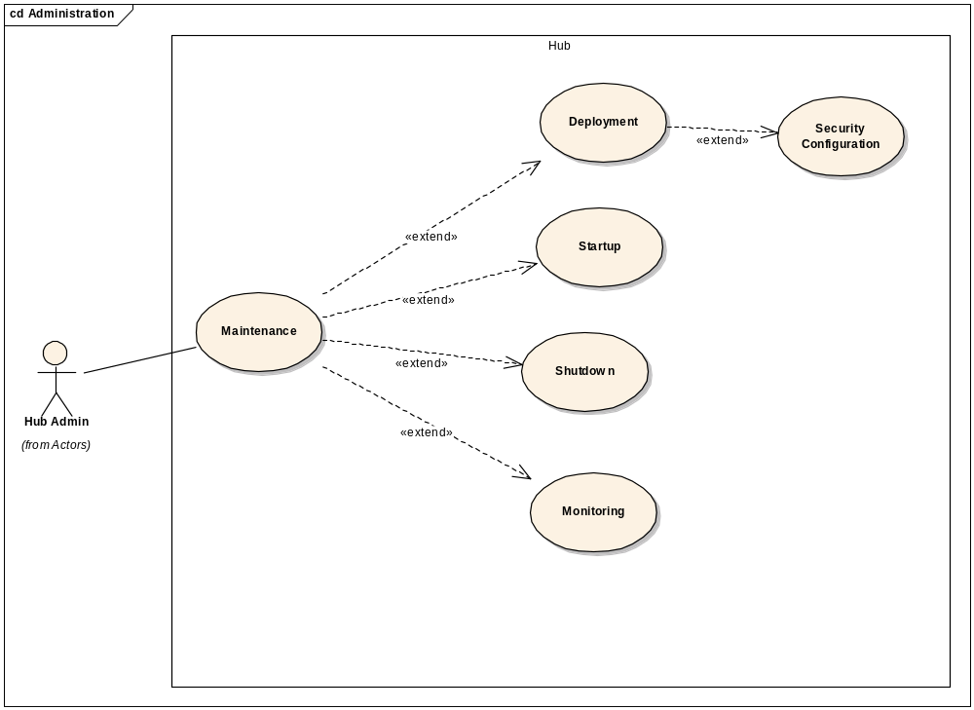
Figure 8 5.3 Administrator Manage caXchange Hub Use Case

USE CASE DESCRIPTION
Use Case Name | Grid Services
Use Case ID | HUBcaXAMH_1.0
Primary Actor | - Administrator
Secondary Actor
Brief Description | Hub maintenance operations are executed
Trigger | - Administrator  - Critical system event (e.g. system level error)  - Period maintenance requirement (e.g. patch)
Pre-conditions | - System requires maintenance
Primary Flow of Events | - Deploy system  - Configure system  - Start system  - Monitor system  - Manage system  - Shutdown system  - Ends
Secondary Flow of Events
Post Conditions | System is operational without impact to users
Branch Point
Associated Quality Requirement(s)
Related Use Cases
Business Rules

BASIC FLOW OF EVENTS:
The basic process flow Administrator Manage caXchange is as follows:
- Deploy system
- Configure system
- Start system
- Monitor system
- Manage system
- Shutdown system
- Ends

SEQUENCE DIAGRAM
- None

Assumptions and Constraints

ASSUMPTIONS
The assumptions of the caXchange and it’s related software components are:
- The NCICB hosted components will be deployed in the shared production NCICB environment.
- The project components will adhere as closely as possible to the published NCICB Future Technology Stack
- The caCORE and caBIG products utilized in this solution are expected to perform their proposed functionality. If there are any product defects, they will be fixed by the respective product team and not the caXchange development team.
- If the appropriate versions of the proposed products that are expected to be used in this solution are not available, a work around must be implemented by the caXchange team, however, the caXchange team will not write replacements for those products.
- ServiceMix 3.1.1 (or 3.1.2) will be used for this caXchange release
- The system being audited will be implemented as a JBI service assembly and deployed to Servicemix.
- caXchange Grid Service described will be implemented as a Grid Service with the WS-Resource framework.
- caGrid services are synchronous.
- JMS provider for the ESB is configured for persistence.
- Inbound Component and Response Component persist requests and responses respectively.

CONSTRAINTS
The dependencies of the caXchange and it’s related software components are described below:

System Specific Use Cases

caXchange Audit Service Use Case
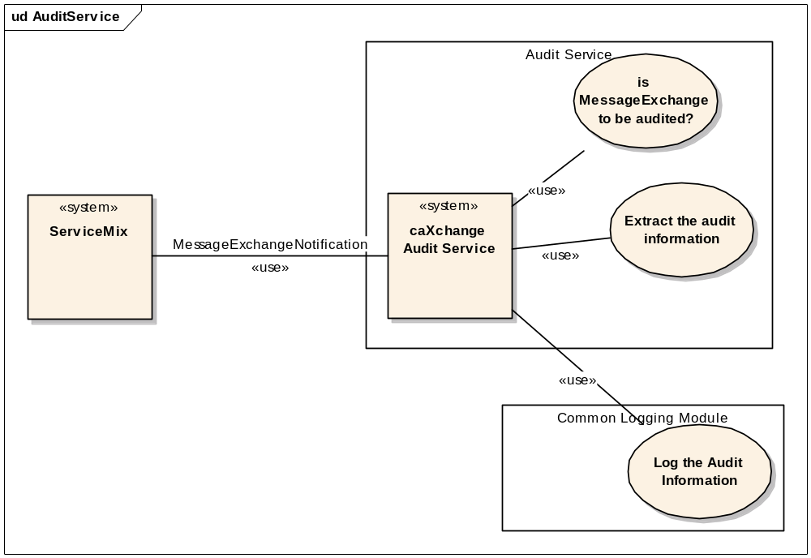
Figure 9 caXchange Audit Service Use Case Diagram

USE CASE DESCRIPTION

Logging caXchange Audit Information
Use Case Name | Grid Services
Use Case ID | HUBcaXAS_1.0
Primary Actor | - caXchange Audit Service – The caXchange message exchange listener which listens for all exchanges between caXchange components.
Secondary Actor | - Inbound Component – The caXchange inbound component that receives incoming messages.  - Servicemix – The Servicemix ESB to which caXchange service assembly is deployed.  - Common Logging Module API – Common logging module api to log audit information.  - Log Locator Application – A common logging module application which enables viewing and searching logs written using the common logging module.  - User – A user who wishes to view caXchange audit information.  - Logging DB – The database to which audit information is logged.
Brief Description | This use case describes audit logging functionality caXchange provides. Its scope is limited to capturing/logging audit information from caXchange, and making this information available to users.
Trigger | An exchange happens in Servicemix.
Pre-conditions | - caXchange Audit Service is deployed and configured to listen and log exchanges occurring in Servicemix.
Primary Flow of Events | - caXchange Audit Service – Gets the notification of a message exchange on Servicemix.  - caXchange Audit Service – Determines based on configuration whether the exchange is to be audited and logged.  - caXchange Audit Service – Extract the audit information from the exchange. This includes the “in” message, and the credentials from the message.  - caXchange Audit Service – Invoke the common logging module API to log the audit information.  - Common Logging Module API – Logs the exchange to the configured logging database.  - Use case ends.
Secondary Flow of Events | Inbound Component Flow  - Inbound Component – Inbound component receives a caXchange message for processing.  - Servicemix – Servicemix alerts caXchange Audit Service of the message exchange to the inbound component.  - caXchange Audit Service – Gets the message exchange and logs it using the common logging module API.  - Use case ends.  Exception Flows  - Exchange is not eligible to log. - Return without logging.  - Exception during Logging. - An Error is thrown so that it is logged in Servicemix log files.
Post Conditions | - The exchange audit information is captured in the logging schema.
Branch Point
Associated Quality Requirement(s)
Related Use Cases
Business Rules

BASIC FLOW OF EVENTS:
The basic process flow caXchange Audit Service is as follows:
- 1. caXchange Audit Service – Gets the notification of a message exchange on Servicemix.
- caXchange Audit Service – Determines based on configuration whether the exchange is to be audited and logged.
- caXchange Audit Service – Extract the audit information from the exchange. This includes the “in” message, and the credentials from the message.
- caXchange Audit Service – Invoke the common logging module API to log the audit information.
- Common Logging Module API – Logs the exchange to the configured logging database.
- Use case ends.

Viewing caXchange Audit Information
Use Case Name | Grid Services
Use Case ID | HUBcaXAS_1.1
Primary Actor | - caXchange Audit Service – The caXchange message exchange listener which listens for all exchanges between caXchange components.
Secondary Actor | - Inbound Component – The caXchange inbound component that receives incoming messages.  - Servicemix – The Servicemix ESB to which caXchange service assembly is deployed.  - Common Logging Module API – Common logging module api to log audit information.  - Log Locator Application – A common logging module application which enables viewing and searching logs written using the common logging module.  - User – A user who wishes to view caXchange audit information.  - Logging DB – The database to which audit information is logged.
Brief Description | This use case describes audit viewing functionality caXchange provides. Its scope is limited to capturing/logging audit information from caXchange, and making this information available to users.
Trigger | A user wishes to view caXchange audit information.
Pre-conditions | - caXchange Audit Service is deployed and configured to listen and log exchanges occurring in Servicemix.  - caXchange Audit information is logged and saved in the common logging module database.  - Log locator application is configured to read the logs from the common logging module database.  - User is setup to log into the log locator application using common security module.
Primary Flow of Events | - User – Logs into log locator application.  - User – User enters query criteria to search for caXchange audit information. User can search caXchange audit information for a particular time.  - Log locator tool – Log locator tool queries the logging database to display the caXchange audit information.  - Use case ends.
Secondary Flow of Events | - User is unable to login to log locator tool. - An appropriate error message is displayed to the user.  - Exception during viewing audit information. - An appropriate error message is displayed to the user.
Post Conditions | - The user is able to view caXchange audit information.
Branch Point
Associated Quality Requirement(s)
Related Use Cases
Business Rules

BASIC FLOW OF EVENTS:
The basic process flow caXchange Audit Service is as follows:
- User – Logs into log locator application.
- User – User enters query criteria to search for caXchange audit information. User can search caXchange audit information for a particular time.
- Log locator tool – Log locator tool queries the logging database to display the caXchange audit information.
- Use case ends.

SEQUENCE DIAGRAM
- See Figure 5 caXchange Query Sequence Diagram and Figure 7 caXchange Client Receive Message Sequence Diagram.

caXchange Authenticate Message Use Case
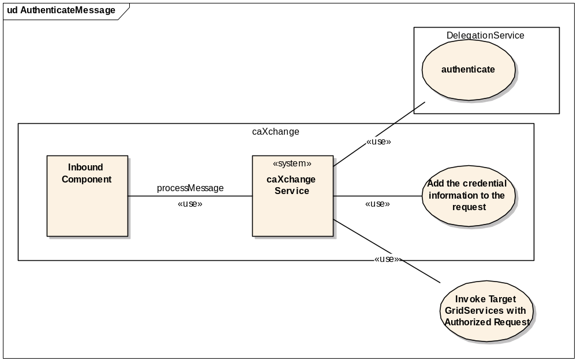
Figure 10 6.2 caXchange Authenticate Message Use Case Diagram

USE CASE DESCRIPTION
Use Case Name | Grid Services
Use Case ID | HUBcaXAM_1.0
Primary Actor | - caXchange Grid Service – The caXchange Grid Service that serves as a proxy for caXchange for incoming requests.
Secondary Actor | - Inbound Component – The binding component that takes incoming requests from the caXchange Grid Service.  - caXchange-Service – The caXchange service that picks up the requests from the Inbound Component, and performs the routing for the request and response.  - Outbound Component - The component that sends the request to the target caGrid service, and returns the response from the target Grid service.  - Delegation Service – The service that is invoked to authenticate user credentials before processing the request to the target caGrid service.  - Response Component – The binding component that gets responses from caXchange-Service and makes them available to the caXchange Grid Service.  - caGrid Service – The target caGrid service that the request is to be routed to.
Brief Description | This use case describes the functionality caXchange provides for authenticating and auhorizing an incoming message for invoking the target Grid services. This document is limited to the caXchange functionality for authenticating and authorizing messages.
Trigger | Inbound Component detects a message from the caXchange Grid service.
Pre-conditions | - caXchange Grid Service is up.  - CCTS service assembly is deployed to ESB, started and running.
Primary Flow of Events | - Inbound Component – Inbound Component receives the message and the message is available for processing for caXchange-Service.  - caXchange-Service – Gets the request from the Inbound Component.  - caXchange-Service – Invokes the Delegation Service to authenticate the user before processing the request. It gets the grid credentials for the user from the Delegation Service.  - caXchange-Service – Includes the grid credentials obtained in step 3 with the message as it is routed to invoke the target caGrid Services.  - caXchange-Service – Routes the authorized request to all the appropriate Outbound Components for invoking the target caGrid Services.  - Use case ends.
Secondary Flow of Events | - Delegation Service is not available. - The caXchange-Service creates an error response including appropriate error message and routes the response to the Response Component.  - Delegation Service fails user authentication/ authorization. - The caXchange-Service creates an error response including appropriate error message and routes the response to the Response Component.  - ESB crashes. - The request messages are picked up for processing when the ESB is brought back up.
Post Conditions | - Processing details are captured in a log.  - The grid credentials are attached to the message for invoking target Grid services.
Branch Point
Associated Quality Requirement(s)
Related Use Cases | - caXchange Outbound Use case  - caXchange Receive Message Use Case  - caXchange Route Message Use Case
Business Rules

BASIC FLOW OF EVENTS:
The basic process flow caXchange Authenticate Message is as follows:
- Inbound Component – Inbound Component receives the message and the message is available for processing for caXchange-Service.
- caXchange-Service – Gets the request from the Inbound Component.
- caXchange-Service – Invokes the Delegation Service to authenticate the user before processing the request. It gets the grid credentials for the user from the Delegation Service.
- caXchange-Service – Includes the grid credentials obtained in step 3 with the message as it is routed to invoke the target caGrid Services.
- caXchange-Service – Routes the authorized request to all the appropriate Outbound Components for invoking the target caGrid Services.
- Use case ends.

SEQUENCE DIAGRAM
- See Figure 5 caXchange Query Sequence Diagram and Figure 7 caXchange Client Receive Message Sequence Diagram.

caXchange Outbound Message Use Case
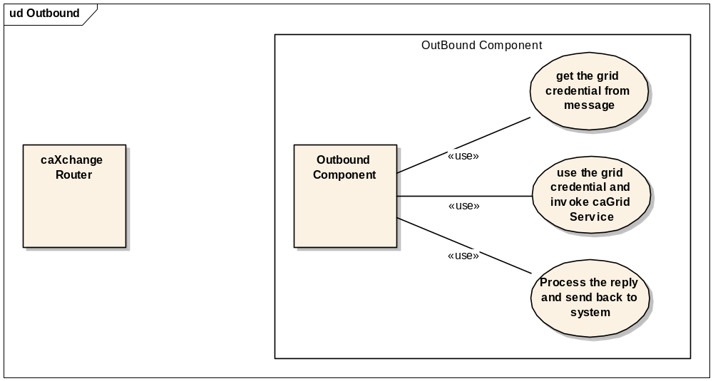
Figure 11 caXchange Outbound Message Use Case Diagram

USE CASE DESCRIPTION
Use Case Name | Grid Services
Use Case ID | HUBcaXOM_1.0
Primary Actor | - Component Client – The actor on whose behalf a caGrid service is invoked.  - System - The component that processes the request.  - caGrid Service – The service being integrated into the ESB infrastructure.
Secondary Actor
Brief Description
Trigger | A client application sends a message destined for the caGrid service.
Pre-conditions | - ESB is up.  - Bean component is installed.  - Service unit for a caGrid service is deployed.
Primary Flow of Events | - Component Client – Sends an InOut message exchange to the system  - System – Validates message.  - System – Gets the grid credentials from the message.  - System – Uses the grid credentials and invokes the caGrid service with the “in” part of the message exchange.  - caGrid Serivce – Processes the messages and sends a reply back to the system.  - System – Creates the “out” part of the message exchange from the reply received from caGrid Service and sends the message on the delivery channel.  - Use case ends.
Secondary Flow of Events | - caGrid Service Not Available  5a System – Fails to connect to the caGrid Service.  6a System – Waits a configured amount of time.  7a System – Tries again.  8a Use case continues from step 5.  - Number of Retries Exceeded  6b System – Creates the “out” part of message exchange specifying a failure to connect to the caGrid service and that the number of retries has been exceeded.  7b Use case ends.  - Grid Credentials not available. - If grid credentials are not available system creates an error message and sends that as the out part of the message exchange.  - Binding Component Crashes  Crash Occurs in Steps 1-4 - If the component crashes before the message is sent to the caGrid service, the message will be sent once the component is back on line and Time to Live (TTL) specified with the message has not been exceeded.  - Crash Occurs after step 5  If the service is idempotent, the crash is handled the same as if the component crashed between steps 1-4.  If the service is not idempotent, the service MUST acknowledge and force removal of the message from the bus at the same time it is sent to the caGrid service. Manual intervention will be required in order to synchronize state between the invoked caGrid service and the client application that sent the original message.
Post Conditions | - Processing details are captured in a log.  - Message exchange “out” part is populated with the result of invocation/invocation attempt of the caGrid service.
Branch Point
Associated Quality Requirement(s)
Related Use Cases
Business Rules

BASIC FLOW OF EVENTS:
The basic process flow caXchange Outbound Message is as follows:
- Component Client – Sends an InOut message exchange to the system
- System – Validates message.
- System – Gets the grid credentials from the message.
- System – Uses the grid credentials and invokes the caGrid service with the “in” part of the message exchange.
- caGrid Serivce – Processes the messages and sends a reply back to the system.
- System – Creates the “out” part of the message exchange from the reply received from caGrid Service and sends the message on the delivery channel.
- Use case ends.

SEQUENCE DIAGRAM
- See Figure 5 caXchange Query Sequence Diagram and Figure 7 caXchange Client Receive Message Sequence Diagram.

caXchange Route Message Use Case
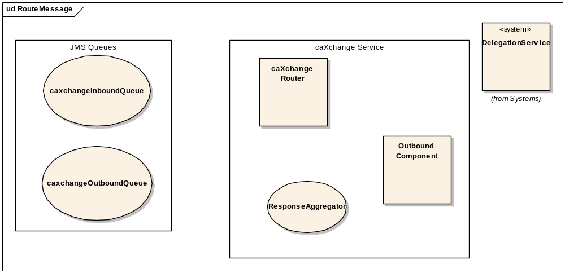
Figure 12 caXchange Route Message Use Case Diagram

USE CASE DESCRIPTION
Use Case Name | Grid Services
Use Case ID | HUBcaXRM_1.0
Primary Actor | - caXchange Grid Service – The caXchange Grid Service that serves as a proxy for caXchange for incoming requests.
Secondary Actor | - Inbound Component – The binding component that takes incoming requests from the caXchange Grid Service.  - caXchange-Service – The caXchange service that picks up the requests from the Inbound Component, and performs the routing for the request and response.  - Outbound Component - The component that sends the request to the target caGrid service, and returns the response from the target Grid service.  - Delegation Service – The service that is invoked to authenticate user credentials before processing the request to the target caGrid service.  - Response Component – The binding component that gets responses from caXchange-Service and makes them available to the caXchange Grid Service.  - caGrid Service – The target caGrid service that the request is to be routed to
Brief Description | Routing a message from the inbound component to the target grid services, and then routing the response back to the outbound component for the client.
Trigger | - caXchange Grid Service sends a request message to the Inbound Component.
Pre-conditions | - caXchange Grid Service is up.  - CCTS service assembly is deployed to ESB, started and running.
Primary Flow of Events | - caXchange Grid Service – Sends a caXchange request message to be processed to the Inbound Component.  - Inbound Component – Inbound Component receives the message and the message is available for processing for caXchange-Service.  - caXchange-Service – Gets the request from the Inbound Component.  - caXchange-Service – Invokes the Delegation Service to authenticate the user before processing the request.  - caXchange-Service – Routes the authorized request to all the appropriate Outbound Components for invoking the target caGrid Services.  - Outbound Component – Invokes the target caGrid Service. The caXchange-outbound-usecase document describes the outbound component functionality.  - caGrid Service – Processes the messages and sends a reply back to the Outbound Components.  - Outbound Component – Sends the response back to the caXchange-Service.  - caXchange-Service – Aggregates the responses from all the Outbound Components and posts the response back to the Response Component.  - Response Component – Makes the response available to the caXchange Grid Service.  - caXchange Grid Service – Gets the response from the response component and makes the response available to the client.  - Use case ends.
Secondary Flow of Events | - caXchange-Service is not available. - The request is saved in the inbound component until the caXchange-Service becomes available to process it.  - Delegation Service is not available. - The caXchange-Service creates an error response with the appropriate error message and routes it back to the Response Component.  - Outbound Component sends back an exception response. - The caXchange-Service sends the exception response to the Response Component. It also determines whether a rollback is required for any target caGrid Services that successfully processed the message. If a rollback is required, a rollback message is created and routed to the appropriate Outbound Components for processing.  - Outbound Component does not send a response back to the caXchange-Service. - The caXchange-Service times out and creates an exception response to send to the Response Component. The timeout for caXchange-Service is configurable. It also determines whether a rollback is required for any target caGrid Services that successfully processed the message. If a rollback is required, a rollback message is created and routed to the appropriate Outbound Components for processing.  - caXchange processing is not complete. - When the client tries to get the caXchange response they are returned an error while caXchange is still processing the request. Once caXchange response is received on the Response Component it is available to the client.  - ESB crashes. - The request messages are picked up by the caXchange-Service when the ESB is brought back up.
Post Conditions | - Processing details are captured in a log.  - The response is available for the client.
Branch Point
Associated Quality Requirement(s)
Related Use Cases
Business Rules

BASIC FLOW OF EVENTS:
The basic process flow caXchange Route Message is as follows:
- caXchange Grid Service – Sends a caXchange request message to be processed to the Inbound Component.
- Inbound Component – Inbound Component receives the message and the message is available for processing for caXchange-Service.
- caXchange-Service – Gets the request from the Inbound Component.
- caXchange-Service – Invokes the Delegation Service to authenticate the user before processing the request.
- caXchange-Service – Routes the authorized request to all the appropriate Outbound Components for invoking the target caGrid Services.
- Outbound Component – Invokes the target caGrid Service. The caXchange-outbound-usecase document describes the outbound component functionality.
- caGrid Service – Processes the messages and sends a reply back to the Outbound Components.
- Outbound Component – Sends the response back to the caXchange-Service.
- caXchange-Service – Aggregates the responses from all the Outbound Components and posts the response back to the Response Component.
- Response Component – Makes the response available to the caXchange Grid Service.
- caXchange Grid Service – Gets the response from the response component and makes the response available to the client.
- Use case ends.

SEQUENCE DIAGRAM
- See Figure 5 caXchange Query Sequence Diagram and Figure 7 caXchange Client Receive Message Sequence Diagram.

Use Case Change Management & Traceability

Overview
It is the responsibility of each caXchange Hub stakeholder to review and validate every element of application development within their purview. This Use Case document is a cornerstone to caXchange Hub development and it is critical that this document be current and concise. In the event that a use case defined by this document is incorrect or requires revision, said correction, and/or revision should be forwarded to the caXchange Hub senior developer and/or architect in the form of a use case change request. The request should include specific information to be added or modified, a detailed explanation for the change, a through representation of the change, identification of the affected actors, and contributing stakeholders. The change request should also include the information necessary to complete the Change Management Tracking Matrices and the Use Case Traceability Matrices. The change request will be assigned a priority and will be incorporated as appropriate in reference to the assigned priority. Once included as document content, the relevant change request information will be added to the matrices.

Change Management Tracking Matrices
Priority | Use Case Name & ID | New/ Mod | Details | Approve/ Reject

Use Case Traceability Matrices
Use Case Name & ID | Details | Requirement Traceability

Overall Requirements

caXchange Component Requirements
Req ID | Requirement Type | Requirement Details | Release # | Use Case ID
1.1 | System | The sender of each message to the caXchange must be authenticated to ensure the system is a known user to the caXchange |  | Authenticate Message
1.2 | System | A check must be performed to ensure that the sender of each message is authorized to perform a defined workflow on the caXchange. |  | Authenticate Message
1.3 | System | An Acknowledgement Response must be returned to the sender indicating the message was successfully received.  A successful audit message will be logged. |  | Receive Message,  Audit Service
1.4 | System | If an error occurred or user authentication or authorization failed, then an Error Response must be returned to the sender indicating the reason why the request failed.  In case of failure,  an error audit message will be logged. |  | Receive Message,  Audit Service
1.5 | System | After a message is received, the message is normalized and routed to the appropriate service on the caXchange. The routing is done based on metadata in the received message. |  | Receive Message,  Route the Message to Destination
1.6 | System | Provide the ability for the Cancer Center Hub Client to specify a workflow that should be executed by the caXchange for a message |  | Route the Message to Destination
1.7 | System | Provide the ability to route an incoming message from the Cancer Center Hub client to the Transformation Service. |  | Route the Message to Destination
1.8 | System | Provide the ability to route the output of the Transformation Service to the CTOM Service |  | Transform the CSV Message to HL7v3 format,  Route the Message to Destination
1.9 | System | Provide the ability to guarantee message delivery to services on the caXchange even in the event of a server shut down |  | Route the Message to Destination
1.10 | System | Provide the ability to a developer to define routing of a message on the hub without writing new code. |  | Route the Message to Destination
1.11 | System | The system must support the concept of a normalized message. A normalized message meaning a common message interface or construct that the caXchange can route to services deployed on the caXchange. |  | Route the Message to Destination
1.12 | System | Ensure that transformation service is available on the caXchange such that future transformations can be plugged in (such as HL7 V# - BRIDG, or HL7-V3 to Oracle-HTB)
1.14 | System | Audit the occurrence of invalid messages from the transformation service to a audit/log data store. |  | Audit Service
1.15 | System | Audit a summary of the transformation process. The audit should provide a count of records that were processed successfully and unsuccessfully. The audits should list the MRN’s of the records that were processed successfully and unsuccessfully. |  | Audit Service
1.16 | System | Provide a user interface to readily map an input lab’s incoming .csv message format to the HL7v3 CT Laboratory Observation Periodic Report message format. |  | Provided by the caAdapter product
1.17 | System | Provide the ability to retrieve data concerning Studies and Investigators from the C3PR system deployed at the Lombardi Cancer Center utilizing the C3PR caCORE query APIs. This data will then be added to the HL7v3 message instance(s) |  | To be done in the caAdapter product or the client  Obtain Missing Protocol Data  (This requirement may not be necessary if it is determined that the Lombardi Cancer Center can provide this information in an the input .csv lab file).
1.18 | System | If a patient belongs to multiple trials the caXchange will be able to receive a HL7v3 message instance for each trial. The lab data will eventually be persisted for every trial the patient belongs to. | 0.5 (Iteration 2) | Done by the Cancer Center Client  Obtain Missing Protocol Data,  Transform the CSV Message to HL7v3 format
1.19 | System | Provide the ability to view the audit/log data repository for audits and logs in a specified period of time |  | Audit Service,  (Functionality provided by the CLM product)
1.20 | System | Each Cancer Center should only be able to view their respective audits/logs. |  | Audit Service
1.21 | System | Provide a service (Audit/Log Service) on the caXchange that has the responsibility for receiving messages (Audit Messages) from any other service on the caXchange containing audit/log data in a common format. |  | Audit Service
1.22 | System | The Audit/Log Service will persist the audit/log data received in the message in a common audit /log data store. |  | Audit Service
1.23 | System | If the Audit/Log Service receives a message with a “fatal” alert level, the service will notify the Hub Administrator or other support personnel of the fatal conditions via e-mail |  | Audit Service
1.24 | System | Audit requests sent to any  service on the ESB without the service actually pushing messages to the audit  service. |  | Audit Service
1.25 | System | Ensure the retrieval of the credential information from  the message is possible |  | Audit Service  (All of the components on the hub will be enhanced to be able to retrieve user identity from  incoming messages)

caXchange Hub Administrator
Req ID | Requirement Type | Requirement Details | Release # | Use Case ID
4.1 | System | The caXchange must provide the ability to deploy new services on the caXchange without disrupting processing of existing services and messages |  | Deployment
4.2 | System | The caXchange must provide the ability to uninstall new services on the caXchange without disrupting processing of existing services and messages |  | Deployment
4.3 | System | The caXchange must provide the caXchange Administrator the ability to shutdown the caXchange |  | Shutdown
4.4 | System | The caXchange Administrator must be given the opportunity to view caXchange performance via a GUI console |  | Monitor
4.5 | System | The caXchange Administrator must be given the ability to see if services on the caXchange are installed, uninstalled, or running. |  | Monitor
4.6 | System | The caXchange Administrator must be given the ability to view the number of messages a service on the caXchange has received. |  | Monitor
4.7 | System | The caXchange Administrator must be given the ability to view the number of messages a service on the caXchange has sent out |  | Monitor
4.8 | System | The caXchange Administrator must be given the ability to view the number of inbound messages a service receives per second. |  | Monitor

